

TASCO Motor Insurance Growth Platform · TGP-BUS-06
Personas and Customer Journeys
Date – 07 October 2026
Version – 1.0
Prepared by – iorta TechNXT
TABLE OF CONTENTS
1. Document Control 3
2. Acronyms 3
3. Introduction 4
3.1. Purpose 4
3.2. Scope 4
3.3. Audience 4
3.4. Related documents 4
4. Persona index 4
5. Customer personas 5
5.1. PC-1 Anh Minh, 38, Hà Nội: private car owner and commuter 5
5.2. PC-2 Chú Hùng, 51: long-haul driver between Thanh Hóa, Hà Nội and Hải Phòng 6
5.3. PC-3 Chị Thảo, 32, TP. Hồ Chí Minh: new car buyer 6
5.4. PC-4 Anh Tuấn, 45, Bình Dương: lapsed owner 6
5.5. PC-5 Chị Lan, 41: fleet manager at a logistics company with 40 vehicles 7
6. Staff and partner personas 7
6.1. Goals and pains 7
6.2. What they do on the platform 8
7. Customer journeys 9
7.1. Renewal of a TASCO policy (PC-1) 9
7.2. Conquest: insured elsewhere or insurer unknown (PC-1, PC-2) 12
7.3. Uninsured recovery (PC-4) 12
7.4. New vehicle onboarding (PC-3) 14
7.5. Cross-sell after purchase 14
7.6. Fleet (PC-5) 15
8. Staff journeys 15
8.1. A telesales agent’s day 15
8.2. Rule author and approver changing the scoring 15
9. Service blueprints 16
9.1. Renewal and conquest 16
9.2. New-vehicle onboarding through a showroom 18
10. Pain points and design responses 20
11. Moments of truth 21
12. Sign-Off 23

Document Control

Date | Version | Author & Business Unit Info | Reviewed By & Business Unit Info | Approved By & Business Unit Info | Change History
07/10/2026 | 1.0 | iorta TechNXT  Business Analysis and User Experience | TASCO Insurance  Product Owner | TASCO Insurance  Programme Sponsor | Initial issue for submission

Acronyms

Acronym / Symbol | Definition / Meaning
API | Application Programming Interface
B2B | Business to business
FR | Functional requirement
ID | Identifier
IT | Information technology
KPI | Key performance indicator
MPV | Multi-purpose vehicle
OTP | One-time password
QR | Quick response (code)
SEG | Growth segment
SMS | Short message service
TNDS | Compulsory motor third-party liability insurance (Bảo hiểm TNDS bắt buộc)
UX | User experience
VAT | Value-added tax

Introduction

Purpose
This document describes the people the TASCO Growth Platform serves and the journeys it gives them. It sets out five customer personas and thirteen staff and partner personas, compares today’s journeys with the future journeys, shows how the service works behind each journey, and lists the pain points and moments of truth the design responds to.

Scope
Customer journeys for renewal, conquest, uninsured recovery, new-vehicle onboarding, cross-sell and fleet, and the working journeys of telesales agents, rule authors and approvers. Screen navigation and task flows belong to TGP-UX-03 Information Architecture and Navigation.
The personas are proto-personas. They are built from the client brief (6 million drivers, 70 to 80% app use, a discount mindset, distrust of sales calls, partner-led sales, near-zero own-channel renewals) and from the behavioural signals the platform uses: toll trips, long trips, app sessions, wallet balance, auto top-up, consent and complaints. Names, ages and quotes are illustrative and are validated with customer interviews and telesales call reviews in discovery. Sentiment scores in the journey diagrams run from 1 (very negative) to 5 (very positive) and are design hypotheses.

Audience
The TASCO product owner, campaign managers, the telesales lead, compliance, and the iorta TechNXT business analysis and UX team.

Related documents
ID | Title
TGP-BUS-01 | Business Context and Growth Strategy
TGP-BUS-02 | Functional Requirements Specification
TGP-BUS-04 | User Stories and Acceptance Criteria
TGP-UX-03 | Information Architecture and Navigation
TGP-UX-04 | Usability Testing Plan

Persona index
ID | Persona | Type | Segment (TGP-BUS-01) | Platform role
PC-1 | Private car owner, commuter | Customer | SEG-3 renewal, SEG-4 conquest | Customer
PC-2 | Long-haul driver | Customer | SEG-3 or SEG-4, roadside-led | Customer
PC-3 | New car buyer | Customer | SEG-2 new vehicle, SEG-7 partner-led | Customer
PC-4 | Lapsed owner | Customer | SEG-1 lapsed or uninsured | Customer
PC-5 | Fleet manager | Customer (B2B) | SEG-6 fleet | Fleet portal in the scale phase
PS-01 | Telesales agent | Staff | None | Telesales agent
PS-02 | Telesales supervisor | Staff | None | Telesales supervisor
PS-03 | Campaign manager | Staff | None | Campaign manager
PS-04 | Rule author (product) | Staff | None | Rule author
PS-05 | Compliance approver | Staff | None | Rule approver, compliance officer
PS-06 | Data steward | Staff | None | Data steward
PS-07 | Claims handler | Staff | None | Claims handler
PS-08 | Partner manager | Staff | None | Partner manager
PS-09 | Partner staff using the API (bank or showroom) | External | SEG-7 | Partner system
PS-10 | Executive | Staff | None | Executive
PS-11 | Support engineer | Staff | None | Support engineer
PS-12 | Platform admin and security | Staff | None | Admin
PS-13 | Internal auditor | Staff | None | Auditor

Customer personas

PC-1 Anh Minh, 38, Hà Nội: private car owner and commuter
Dimension | Detail
Vehicle and use | Five-seat sedan; commutes and makes weekend trips; 15 to 25 toll trips a month
Digital habits | Opens the VETC app weekly to check his balance and top up; uses Zalo daily
Insurance today | Bought TNDS last year from a bank partner with his car loan, or at the inspection centre. Does not remember the expiry date or the insurer
Goals | Stay legal at inspection and roadside checks with no effort
Pain points | “Everyone calls me to sell insurance.” Does not know when his cover ends. Paper certificates get lost. Believes he should get a percentage off
Triggers to act | Inspection booking; wallet top-up; a credible reminder with an exact date
What wins him | Purchase in a trusted app, an instant e-certificate, no calls, roadside assistance
Signals the platform sees | Medium app sessions and toll trips; app push enabled; marketing consent given
Typical next best action | Ask customer to confirm expiry (if confidence is below 0.5), then a one-tap renew link by app or Zalo

PC-2 Chú Hùng, 51: long-haul driver between Thanh Hóa, Hà Nội and Hải Phòng
Dimension | Detail
Vehicle and use | Seven-seat MPV, often carrying family or passengers; more than 2,000 highway km a quarter
Digital habits | Uses the VETC app for wallet auto top-up; prefers calls to reading
Goals | Help on the road if the car breaks down; passengers protected
Pain points | Breakdowns far from home; unsure what TNDS covers (it does not cover his passengers or his own car)
What wins him | 24/7 roadside assistance, made relevant by his long trips and toll use; personal accident cover per seat for seven seats; later, never-lapse auto renewal (roadmap)
Signals the platform sees | Many highway kilometres over 90 days, auto top-up on, wallet balance above the premium
Typical next best action | AI voice assistant then telesales if hot with call consent; otherwise a one-tap renew link

PC-3 Chị Thảo, 32, TP. Hồ Chí Minh: new car buyer
Dimension | Detail
Moment | Has just taken delivery; the showroom fitted the VETC tag, which sends a tag-activated event
Insurance today | The showroom sold TNDS, and possibly physical damage cover, at delivery
Goals | Protect a new and expensive car; avoid paperwork
Pain points | Paperwork overload at delivery; unclear what she bought and until when
What wins her | A welcome message that stores her cover in the app; physical damage cover for a car five years old or less; inspection reminders
Channel | Showroom through the partner API, then the VETC app
Typical journey | New vehicle: welcome at day 1, confirm expiry at day 7, value reminder at day 14

PC-4 Anh Tuấn, 45, Bình Dương: lapsed owner
Dimension | Detail
Situation | His TNDS expired three weeks ago. He forgot, or lets it lapse until inspection
Attitude | Suspicious of calls (“is this a scam?”); focused on price
Risk | Fines at roadside checks; inspection refused; personally liable after an accident
What wins him | A clear, unpressured service notice with an “I already bought it, tell us” option; a quick fix in the app; an assistant that proves it is genuine by asking for his plate first
Typical journey | Uninsured recovery: notice today, assistant call at day 2 (hot or warm), telesales at day 5 (hot)
Typical next best action | Urgent: vehicle uninsured

PC-5 Chị Lan, 41: fleet manager at a logistics company with 40 vehicles
Dimension | Detail
Situation | Company-owned trucks and vans, each renewing on a different date
Goals | No vehicle off the road for lack of TNDS; one invoice; one contact
Pain points | Spreadsheet tracking; many invoices; individual sales calls to her drivers
What wins her | An account manager in the B2B team now; a fleet dashboard with one view and a consolidated VAT invoice in the scale phase
Channel | B2B team; partner type fleet
Treatment | Excluded from consumer journeys and assistant campaigns

Staff and partner personas

Goals and pains
ID | Persona | Goals | Pains today
PS-01 | Telesales agent | Close more with fewer calls | Cold lists; customers distrust calls; cannot take payment
PS-02 | Telesales supervisor | Team productivity and compliance | No view of lead quality or script adherence
PS-03 | Campaign manager | Grow policies at a controlled cost | No reliable expiry data; blunt campaigns
PS-04 | Rule author (product) | Change scoring, journeys and wording quickly and safely | An IT ticket for every change
PS-05 | Compliance approver | Nothing unlawful reaches a customer | Manual review of wording; opaque automated calls
PS-06 | Data steward | Customer data the business can trust | Duplicates; one record in ten verified
PS-07 | Claims handler | Fast and complete first notices | Late, incomplete notifications
PS-08 | Partner manager | Grow partner sales; settle commission cleanly | Manual statements; disputes
PS-09 | Partner staff using the API | Close insurance with the main sale | Re-keying data; slow issuance
PS-10 | Executive | Visible growth and return on investment | Anecdotal reporting
PS-11 | Support engineer | A stable platform | Silent integration failures
PS-12 | Platform admin and security | Least-privilege access | Shared accounts
PS-13 | Internal auditor | Evidence on demand | Scattered, editable logs

What they do on the platform
ID | Jobs on the platform | Main screens | Success measure
PS-01 | Work hot, verified, interested customers with talking points; send the quote to the customer’s VETC app during the call | Telesales inbox, Customer 360 | Handoff win rate (K-08); first contact within 2 business hours
PS-02 | Assign handoffs; rehearse assistant scripts; monitor outcomes | Telesales inbox, Voice assistant | Win rate; service-level adherence
PS-03 | Prioritised queue, journeys, assistant campaigns, event simulator, economics | Leads, Journeys, Voice assistant, Dashboard | K-00, K-10
PS-04 | Draft, validate, simulate and submit rule changes | Business rules | Rule-change lead time of one day or less
PS-05 | Four-eyes approval; copy guard; governance KPIs; data-subject requests | Approvals, Audit, governance dashboard | No copy-guard or contact-policy breaches
PS-06 | Ingest data; work the data-quality queue; lineage; corrections with evidence | Data quality, Customer 360 | K-01 usable-expiry rate
PS-07 | Accident-report queue and status changes within the acknowledgement time | Claims | Share acknowledged within 4 hours
PS-08 | Onboard partners, issue keys, suspend, review statements | Partners | Active partners on the API; no disputes
PS-09 | Quote by plate, bind, instant e-certificate, statement | Partner API | Time to certificate under one minute
PS-10 | Growth, channels, economics, adoption | Dashboard | K-00, premium, cost per policy
PS-11 | Integration status, jobs, reconciliation | Operations | Service levels (TGP-BUS-03)
PS-12 | Users, roles, regions, lockout and two-factor reset | Users | No orphan accounts; two-factor coverage of privileged roles 100%
PS-13 | Audit search; hash-chain verification | Audit | Chain verifies daily

Customer journeys
In the journey diagrams, each row is a stage and the fill colour shows how the customer feels at each step, on a scale from 1 (dark red, very poor) through 3 (amber, neutral) to 5 (dark green, very good).

Renewal of a TASCO policy (PC-1)
Today Anh Minh receives no reminder from TASCO, or one with the wrong date. The diagram shows how that feels.
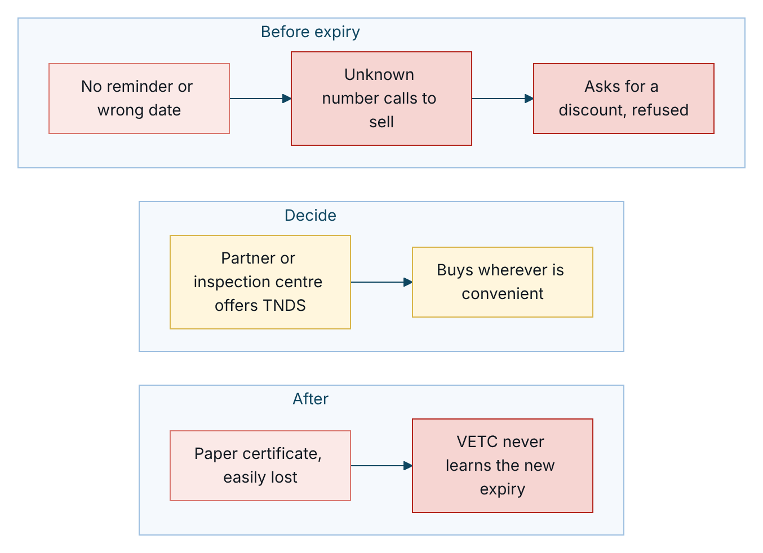
Figure 1 – Renewal today, step by step, coloured by how the customer feels
With the platform, the renewal starts in the app he already uses, at the right time, and ends in a purchase without a phone call.
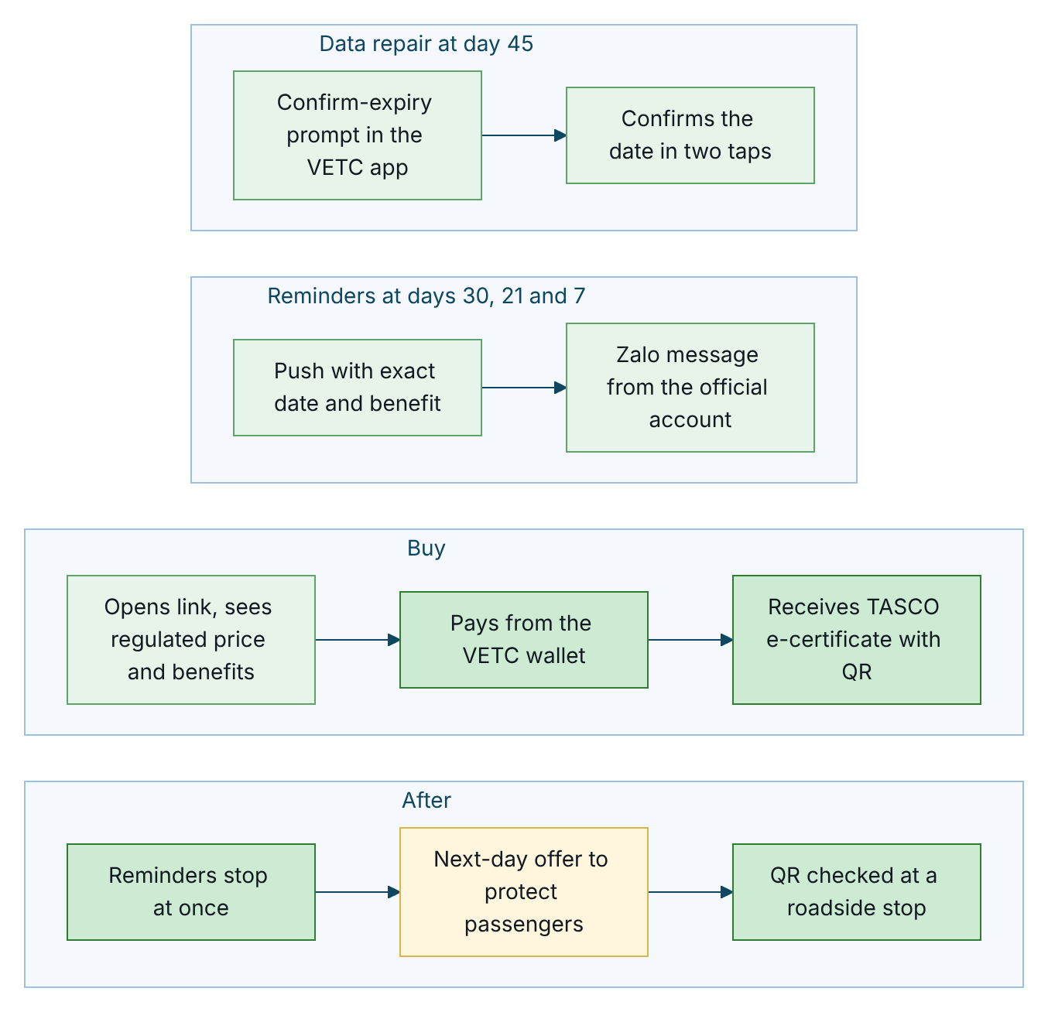
Figure 2 – Renewal with the platform, from the data-repair prompt to the roadside check

Stage | Touchpoint | Customer doing and feeling | Pain point | Design response | Measure
Day 45: verify | Verify-expiry service message by push or Zalo | Confirms or corrects expiry; “how do they know?” is answered by the VETC app context | A wrong date erodes trust | Data repair in ten seconds | Confirmation rate
Day 30: first reminder | First reminder by push, Zalo or SMS | Notices it; may renew straight away | Too many messages | Caps of one a day and three a week; renew in three taps or fewer | Click-through, conversion
Day 21: value | Value reminder | “Same price everywhere, so what else do I get?” | Generic benefits | Benefits chosen for this driver, with the reason | Conversion
Day 14: assistant | Assistant call (hot or warm) | Suspicion turns to trust; verifies plate, asks price, chooses link or adviser | Plate misheard | Plate first, three attempts, link option | Outcomes, opt-out rate
Day 7: urgent | Urgent reminder | Mild urgency; renews in the app | Payment friction | Wallet payment, idempotent | Conversion
Day 3: telesales | Telesales call (hot) | Wants help or reassurance | Feels like a sales call | Talking points, trust script, quote sent to the app, no payment by phone | Win rate
Day 0: expiry | Expiry-day service message | Worried about fines | None | Clear lapse message, no scare tactics | Lapse rate

All steps stop as soon as the vehicle has an active TASCO TNDS policy; any touchpoint that falls due afterwards is cancelled with the reason “already insured with TASCO”. The target is renewal in three taps or fewer from the reminder (NFR-035).

Conquest: insured elsewhere or insurer unknown (PC-1, PC-2)
Steps run at 45, 30, 21, 14 (assistant call, hot leads only) and 7 days before expiry. The conquest reminder invites the driver to renew “lần này” (this time) in the VETC app with TASCO, together with the top benefit for that driver. The emotional curve moves from indifference (“I always renew at the inspection centre”) to curiosity (convenience, roadside assistance), and the decision often comes at day 7 if the wallet covers the premium. The key moment is a wallet top-up within 30 days of expiry: the customer is in the app with funds, and the first reminder arrives by push.

Uninsured recovery (PC-4)
Today the lapse goes unnoticed until a roadside check or an inspection.
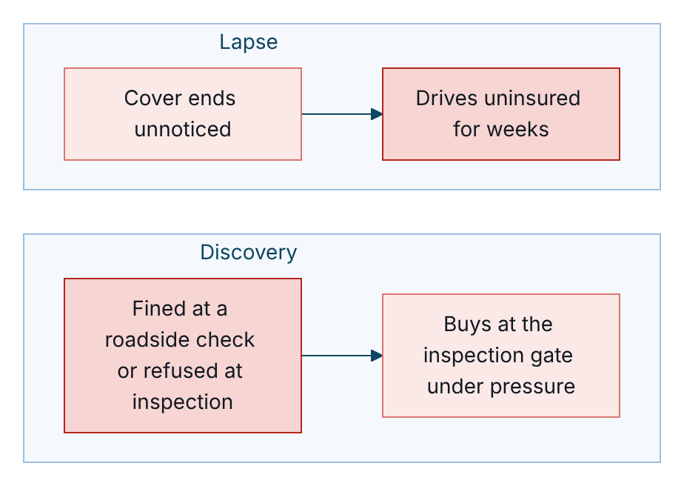
Figure 3 – An uninsured vehicle today, coloured by how the customer feels
With the platform, Anh Tuấn hears about it first from VETC, in a helpful tone, and can fix it in the app.
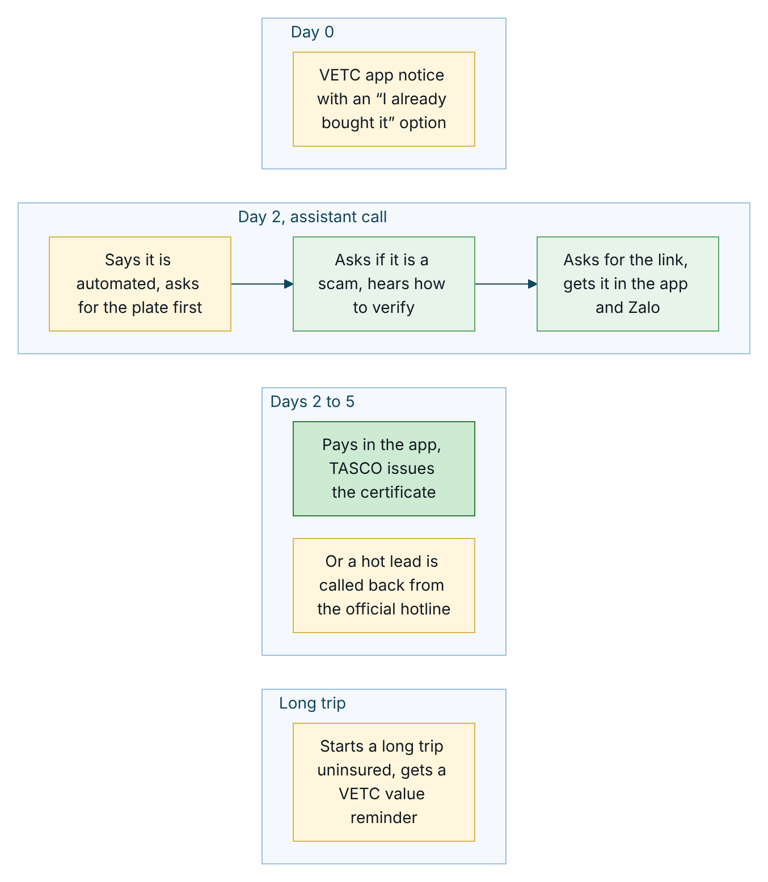
Figure 4 – Uninsured recovery with the platform, from the day-0 notice to the long-trip reminder
The recovery journey applies to vehicles lapsed up to 60 days: a lapsed notice on day 0, an assistant call on day 2 (hot or warm) and a telesales call on day 5 (hot). The first action offered is “I already bought it”, which repairs the data and stops the reminders. The tone is helpful, never accusatory.

New vehicle onboarding (PC-3)
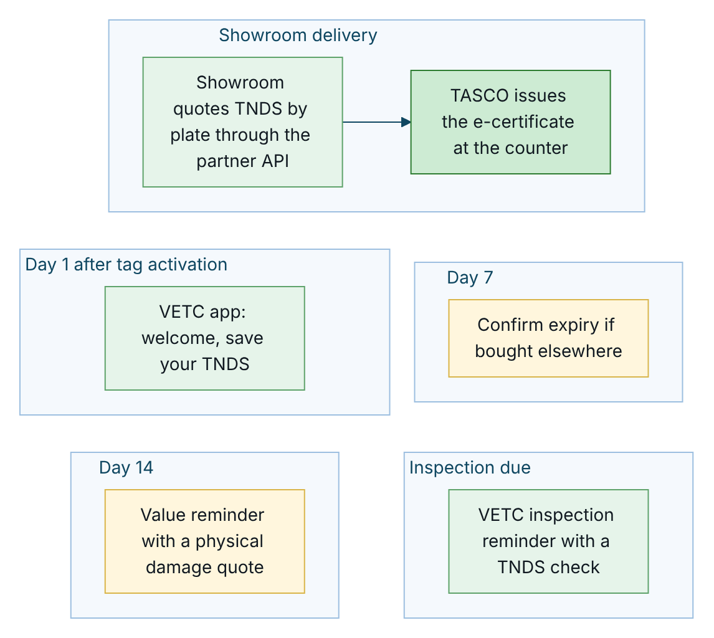
Figure 5 – New vehicle with the platform, from the showroom to the inspection reminder
A new tag usually means a new car, so the tag-activated event enrols the vehicle. If the showroom sold the TNDS through the partner API, the partner record raises the expiry confidence and the platform does not pitch TNDS again. Physical damage cover can be quoted at once but is paid only after a vehicle inspection has been recorded.

Cross-sell after purchase
The day after a TNDS-only purchase, and only with marketing consent, the customer receives a message that TNDS protects only third parties, with an offer of personal accident cover per seat or physical damage cover. It is never sent if add-ons were already bought.

Fleet (PC-5)
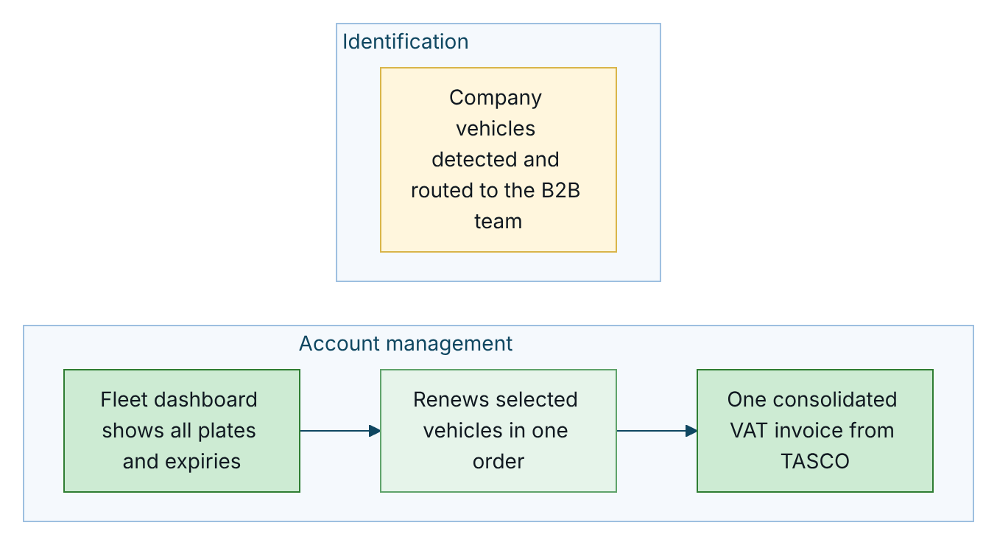
Figure 6 – Fleet with the platform, coloured by how the B2B team and the fleet manager feel
Routing to the B2B team and exclusion from consumer journeys are in place today. The fleet dashboard and consolidated invoice are in the scale phase.

Staff journeys

A telesales agent’s day
Time | Activity | Platform support | Feeling
08:00 | Signs in | Lands on the telesales inbox, filtered to her region | Neutral
08:15 | Claims the first hot handoff | Verified plate, “customer asked about price”, talking points | Confident: this customer asked for a call
08:20 | Calls | Trust script; official hotline | Relief: the customer expects the call
08:30 | Prepares a quote and sends it to the customer’s app | Sell tab with benefits; quote priced by TASCO core; “Send to customer” | Efficient: the customer pays in the app while still on the line
08:35 | Records the outcome | Won or callback, with a note | Accomplished
11:00 | Calls back | Handoffs in callback status | In control
17:00 | Reviews the day | Supervisor dashboard; wins recorded | Recognised

Rule author and approver changing the scoring
The author has an idea (“long-distance drivers convert better”), drafts the change in the rules studio, validates it, simulates it on five customers and submits it with a description. The approver receives a notification, reviews the differences and the simulation, and approves with a comment. The change is active within seconds and leads are recomputed. There is no IT ticket, no release and no spreadsheet. Self-approval is impossible, and every step is in the audit trail.

Service blueprints

Renewal and conquest
The lanes show who acts at each stage, from the data-repair prompt to the e-certificate, and what happens when the customer does not respond to digital reminders. The first diagram covers data repair and reminders, the second the purchase.
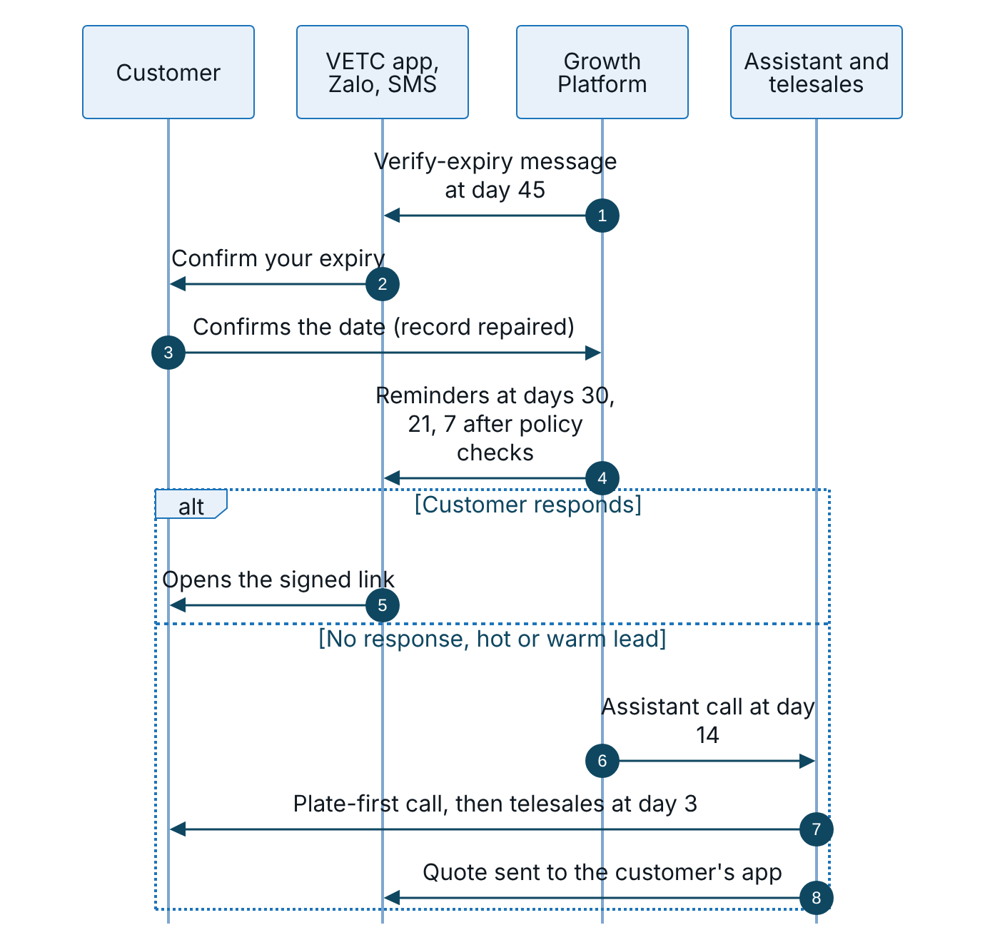
Figure 7 – Renewal and conquest, part 1: data repair and reminders
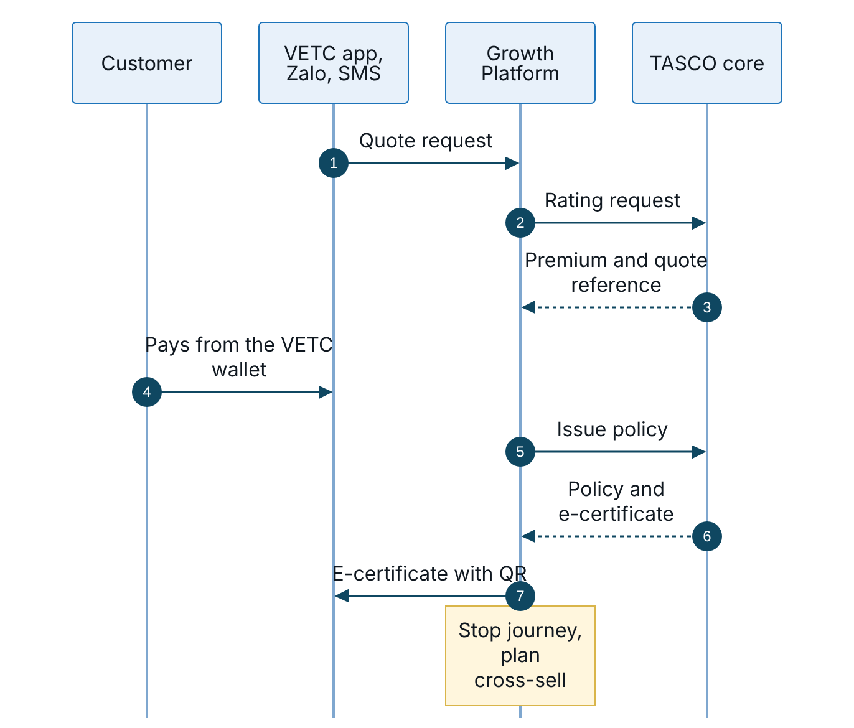
Figure 8 – Renewal and conquest, part 2: quote, payment and issuance
Stage | Customer action | Frontstage | Behind the scenes | Fail point and mitigation
Data repair (day 45) | Confirms expiry | Verify-expiry message by push or Zalo | Record updated at confidence 0.75; lead recomputed | Customer ignores it: expiry estimated from inspection cycle and tag anniversary; the assistant asks “which month?”
Reminders (days 30, 21, 7) | Reads and opens the link | First or conquest reminder, value reminder, urgent reminder | Contact policy and copy guard checked before sending | Cap reached: skipped with the reason. Outside hours: deferred to the next run inside the window
Assistant (day 14; hot or warm for renewal, hot for conquest) | Verifies the plate | Voice assistant | Outcome written back to the record | Plate not recognised: three attempts, then “not verified”. Scam concern: trust script
Telesales (day 3, hot) | Talks to an adviser | Telesales agent | Handoff, quote priced by TASCO core, quote sent to the app | Staff never take payment; the quote goes to the app
Purchase | Pays | Customer app | Quote claimed, wallet debited, TASCO core issues | Wallet slow: circuit breaker. Issuance fails: automatic refund. Core unavailable: no payable quote until re-rated
After sale | Receives the certificate | Purchase confirmation message | Journeys stop; cross-sell planned | None

New-vehicle onboarding through a showroom
The first sequence shows the showroom sale through the partner API; the second shows the tag activation that starts the new-vehicle journey.
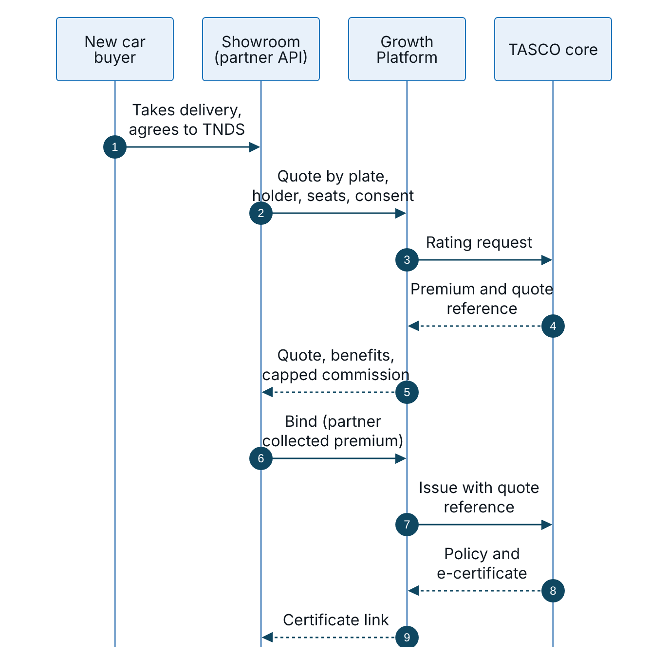
Figure 9 – New-vehicle onboarding, part 1: TNDS sold at the showroom through the partner API
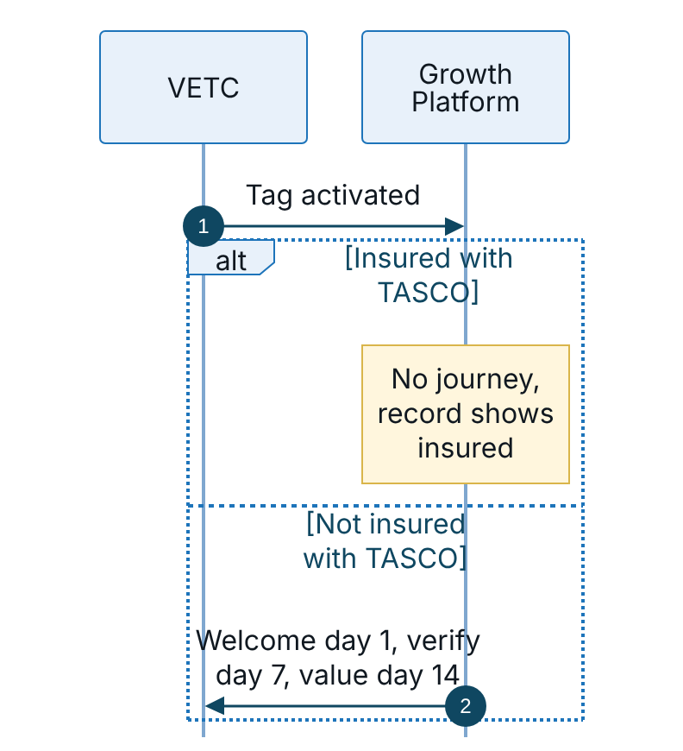
Figure 10 – New-vehicle onboarding, part 2: tag activation starts the journey
Stage | Frontstage | Behind the scenes | KPI
Showroom quote | Partner front end | Quote priced by TASCO core; unknown plate joins the base | Quote-to-bind conversion
Bind | Partner front end | Partner-collected premium; commission capped by rule; physical damage only after inspection | Time to certificate
Tag activation | None | Event re-evaluates the vehicle | New-vehicle enrolment rate
Onboarding messages | VETC app, Zalo | Contact policy checked | K-07
Cross-sell | VETC app | Next-day cross-sell step | K-09

Pain points and design responses
Ref | Pain point | Persona | Design response | Requirements
PP-01 | “I don’t know when my insurance expires.” | PC-1, PC-4 | Expiry estimate with confidence; confirmation in the app; exact date in every reminder | FR-005, FR-076, FR-025
PP-02 | “Unknown callers try to sell me things; it might be a scam.” | PC-1, PC-4 | Disclosure, plate first, trust script, official hotline, no payment on calls | FR-031 to FR-035, FR-040
PP-03 | “I want a discount.” | PC-1, PC-4 | Honest regulated-price answer, relevant service value, copy guard | FR-035, FR-058, FR-024
PP-04 | “Buying is faster at the partner.” | PC-1, PC-3 | Wallet purchase in the app; partner API so partners sell TASCO instantly | FR-077, FR-065
PP-05 | “I lose paper certificates; police doubt screenshots.” | PC-1 | E-certificate with public QR verification | FR-050
PP-06 | “Too many messages.” | All | Caps of one a day and three a week, hours 08:00 to 20:00, consent centre, journeys stop on purchase | FR-023, FR-078, FR-019
PP-07 | “I didn’t know TNDS doesn’t cover my passengers or my car.” | PC-2, PC-3 | Explained cover upgrades and bundles | FR-055, FR-054, FR-028
PP-08 | “My drivers get sales calls; I manage 40 renewals in a spreadsheet.” | PC-5 | B2B routing; exclusion from consumer journeys; fleet dashboard in the scale phase | FR-070
PP-09 | Agent: “My leads are cold and I can’t close on the phone.” | PS-01 | Hot, plate-verified handoffs with talking points; quote sent to the app for the customer to pay | FR-040 to FR-042
PP-10 | Product: “Every change needs IT.” | PS-04 | Rules studio with simulation and maker-checker | FR-082 to FR-087
PP-11 | Compliance: “I can’t review every script and message.” | PS-05 | Copy guard on save and send; versioned scripts; audit chain | FR-024, FR-086, FR-099
PP-12 | Data: “Only one record in ten is verified.” | PS-06 | One record per vehicle, data-quality queue, lineage, data-repair loop | FR-004 to FR-010
PP-13 | Partner: “Commission statements are late and disputed.” | PS-08, PS-09 | Self-service statement; commission capped by rule | FR-067 to FR-069
PP-14 | Claims: “Accidents are reported late with poor information.” | PS-07, PC-1 | Accident reporting in the app with location and photos; acknowledgement within 4 hours | FR-071, FR-072

Moments of truth
Ref | Moment | Who | Why it matters | Platform response
MoT-01 | First 10 seconds of a call | PC-1, PC-4 | Decides trust or hang-up | Automated-assistant disclosure; “VETC never asks for OTP or payment”; asks for the plate and never says it
MoT-02 | The price question | PC-1, PC-4 | Where discount expectations meet the law | Truthful regulated-price answer, then service value
MoT-03 | Tag activation of a new car | PC-3 | Habits form in the first weeks | Welcome, save cover, reminders
MoT-04 | Inspection booking | PC-1, PC-4 | Valid TNDS is required at inspection | TNDS check message
MoT-05 | Wallet top-up | PC-1, PC-2 | The customer is in the app with funds | Renewal reminder by push
MoT-06 | Starting a long trip uninsured | PC-2, PC-4 | Risk is front of mind | Value reminder by push
MoT-07 | Expiry day | All | Legal exposure begins | Service notice that ignores marketing caps
MoT-08 | The payment tap | All | A double charge or a failure destroys trust | Idempotent purchase; quote claimed once; automatic refund if issuance fails (FR-047, FR-048)
MoT-09 | Roadside or inspection check | All | Proof of cover | QR verification page (FR-050)
MoT-10 | An accident | All | The moment that justifies insurance | Accident reporting in the app; acknowledgement message; acknowledgement within 4 hours (FR-071)
MoT-11 | Saying “stop” | All | Respect builds long-term trust | Immediate do-not-contact, audited (FR-036, FR-078)

Sign-Off
Serial Number | Description | Owner | Status
1 | Customer personas validated with 8 to 12 interviews per segment and a review of telesales call recordings | TASCO Product Owner and VETC | Open
2 | Journey timings (45, 30, 21, 14, 7, 3 and 0 days) confirmed for the pilot | TASCO Product Owner | Open
3 | Tone and wording of the lapsed notice approved | TASCO Compliance | Open

Sign Off Date | Signature | Approved By | Department & Project Role
 |  | TASCO Insurance | Programme Sponsor
 |  | TASCO Insurance | Product Owner
 |  | iorta TechNXT | Business Analysis and User Experience



